**Types of Poems**

http://www.fireflygrove.com/graphics/images/021007_ballad.jpg

**Ballad:** This is an old style of writing poetry, which was used to tell stories. A ballad usually has stanzas made up of either seven or eight or ten lines, and ends with a short four or five line stanza. Each stanza ends with the same line, which is called ‘a refrain’.

[](http://images.google.ca/imgres?imgurl=http://www.ursine.com.au/Images/2BearsHug.gif&imgrefurl=http://profile.myspace.com/index.cfm?fuseaction%3Duser.viewProfile%26friendID%3D379744091&usg=__uf-Likex3az30-MCmLPaBtMIDx0=&h=425&w=300&sz=41&hl=en&start=3&tbnid=LNAzKGB2nc_jQM:&tbnh=126&tbnw=89&prev=/images?q%3Dhug%2Bimages%26ndsp%3D20%26hl%3Den%26sa%3DN)

**Couplet:** Perhaps the most popular type of poetry used, the couplet has stanzas made up of two lines which rhyme with each other.

**Quatrain:** This kind of poem has four lines in a stanza, of which the second and fourth lines rhyme with each other and have a similar syllable structure.

[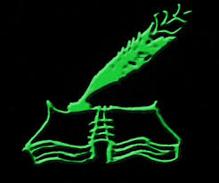](http://www.freewebs.com/free_verse/writing_icon.jpg)**Sonnet:** This type of poem contains fourteen lines and follows conventional structures of rhyme.

[](http://images.google.ca/imgres?imgurl=http://dryicons.com/files/graphics_previews/dreaming_of_freedom.jpg&imgrefurl=http://dryicons.com/free-graphics/preview/dreaming-of-freedom/&usg=__fO75979c9gOJ-8VWCsjO_ljpZBM=&h=529&w=399&sz=52&hl=en&start=4&um=1&tbnid=31Px1FbEbvAXsM:&tbnh=132&tbnw=100&prev=/images?q%3Dfreedom%2Bimages%26um%3D1%26hl%3Den%26sa%3DX)**Free Verse:** This is a method of writing poetry, which does not essentially follow any structure or style. There is no fixed meter and no structure regarding rhyme and lines in each stanza. This kind of poetry is quite popular with modern poets.

[](http://images.google.ca/imgres?imgurl=http://www.southgatearc.org/images/cartoons/laughing.JPG&imgrefurl=http://www.southgatearc.org/humour/index.htm&usg=__FewAcrV0YYU62c43fb0N9tTSYNo=&h=396&w=300&sz=11&hl=en&start=2&um=1&tbnid=j9vDExd9eA4iuM:&tbnh=124&tbnw=94&prev=/images?q%3Dcartoons%2Blaughing%26gbv%3D2%26hl%3Den%26sa%3DX%26um%3D1)**Limerick:** This is a very witty and often vulgar kind of a poem, which is quite short. This poem has five lines in a stanza. The first, second and fifth line have the same metrical structure and they rhyme with each other. They contain seven to ten syllables each. The second and fourth lines have the same metrical structure and rhyme with each other. These contain five to seven syllables.

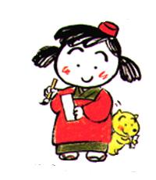**Haiku**: This is a traditional Japanese poetry form that tells about one specific incident, experience or impression. It is a three line poem with 17 syllables, arranged as follows:

Line 1: 5 syllables

Line 2: 7 syllables

Line 3: 5 syllables

**Tanka** : This is a longer haiku that tells about one specific incident, experience, or impression. It is a five-line poem with 31 syllables arranged as follows:

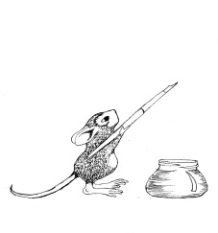 Line 1: 5 syllables

Line 2: 7 syllables

Line 3: 5 syllables

Line 4: 7 syllables

Line 5: 7 syllables



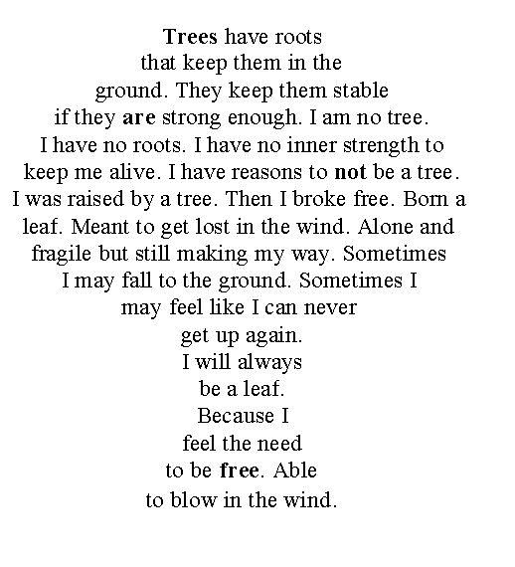

**Concrete Form Poems** : These are usually free verse poems. Visual imagery is enhanced for the reader by the way the poem is written on the page; the poem is written in the shape of its subject. Sometimes they imitate the movement of the object.

***Cinquain:*** *This is another unique type of poetry style. As the name suggests, it is made up of five lines. The first line is just one word, which is often the title of the poem. The second line has two words which describe the first line. The third line has three words, and is mostly the action part of the poem. The fourth line is four words describing the feelings. And the fifth line, again, has just one word which is the title of the poem.*